Tableau Dashboards Documentation

## **1. Analytics Team**

*Team members:* Anh Quan Hua

Anh Linh Le

Bowen Li

Xiaolu Li

Gouri Nandan Reddy Gangavaram

## **2. Introduction**

*Definitions*: Tableau Dashboards are compact views consisting of many different visualizations that aim to help users to quickly grasp the main insights to be showcased. Since our analysis report contains visualizations that might not be easily interpret to a wide range of viewers, our Tableau Dashboards are created to highlight more obvious answers to

*Implementation*: With how our datasets are structured, it is crucial to clean the data to remove null and misleading data before using it. In this documentation, we will provide in-depth details (provided by respective member for each dashboard) to the formation of the Dashboards.

*Limitations*: Regardless of our outcomes, Tableau is a fantastic tool for producing meaningful visualizations. The main limitation here is first our team’s skill in Tableau as some members just started to learn and research about Tableau at the beginning of the project. The second limitation is that the original data (csv files) obtained from Kaggle, might not be the most suited to be immediately visualized in Tableau – thus further analysis/processing is required.

*Data sources:* Fitbit Tracker Data:

<https://www.kaggle.com/datasets/arashnic/fitbit>

Video Game Sales 2019:

<https://www.kaggle.com/ashaheedq/video-games-sales-2019>

Video Game Sales 2016:

<https://www.kaggle.com/dileepsahu/video-games-sale-data-set-dec-2016>

Video Game Sales 2017:

<https://www.kaggle.com/gregorut/videogamesales>

## **3. Dashboards**

### a. Fitbit Tracker Data Dashboard – Anh Quan Hua

**Link to public dashboard:** <https://public.tableau.com/app/profile/quan.h5693/viz/FitbitTrackerWorkbook/Dashboard1>

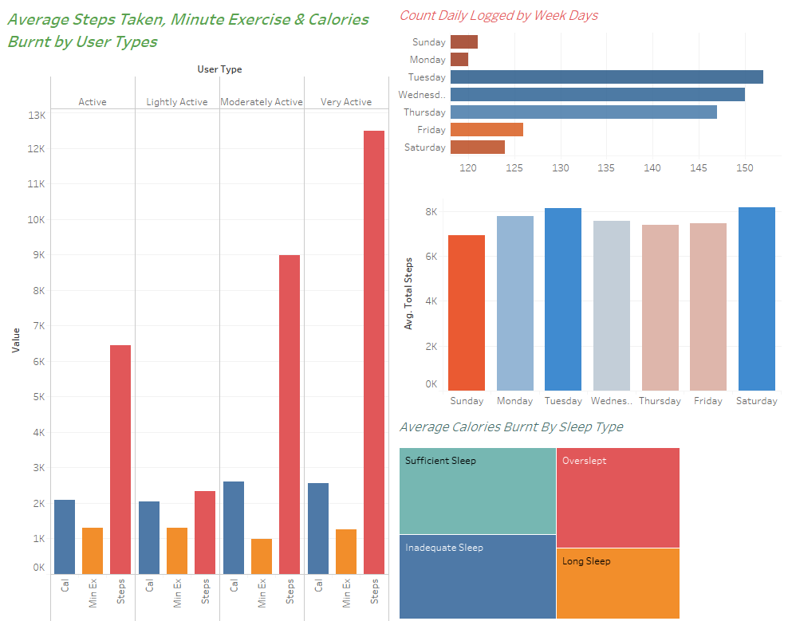

**Data used**: Fitbit Tracker Data.

**Data Pre-processing**:

Refer to our Jupyter Notebook titled ‘Fitbit Tracker Data Analysis’ for the complete view of the processing work. In this documentation, we are going through code cells that produce the CSV files used in the dashboard only. Data tables used in this dashboard are products of merging, processing and cleaning the raw datasets.

First, define the part to our original files obtained from Kaggle:

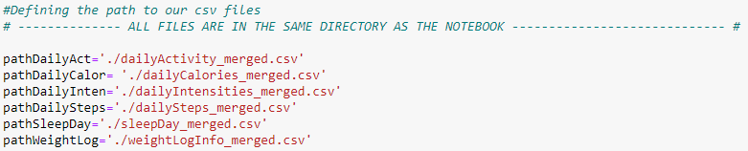

Then, we read the CSV files:

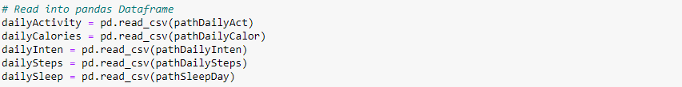

Next, perform some formatting and produce the CSV:

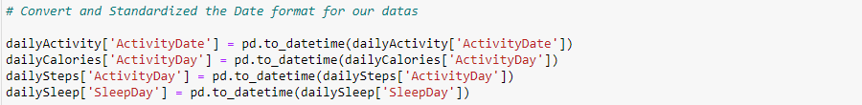

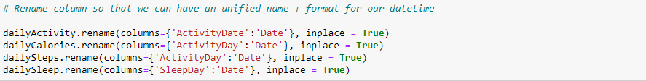



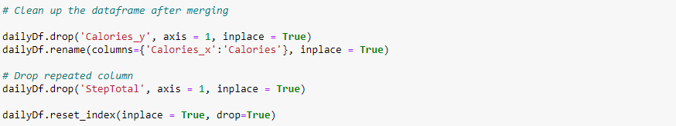

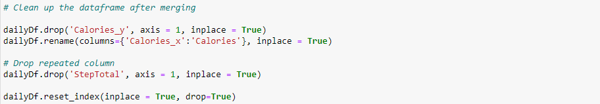

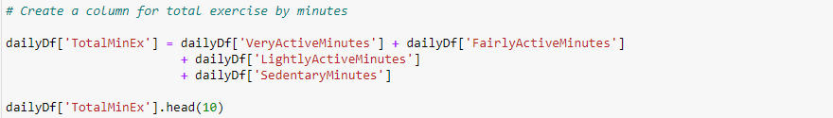

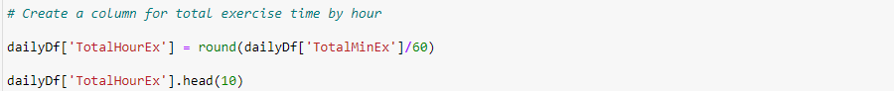

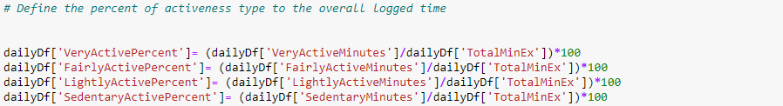



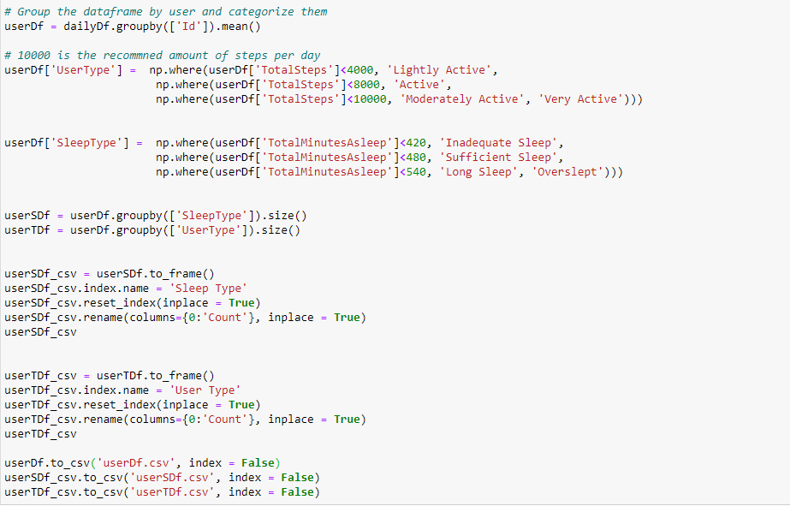 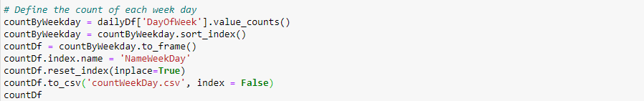

After all the previous steps are taken, you should have the following 5 CSV files: countWeekDay.csv, dailyDf.csv, userDf.csv, userSDf.csv and userTDf.csv.

Finally, access the link to the dashboard on Tableau Public, download the workbook to see how these text files are used for our showcase.

**Graph Details:**

*1st Graph:*

This graph details the average of total steps taken, total minute spent exercising and total calories burnt by the type of user – which is defined by their activeness. We can see that the amount of calories burnt, on average, typically increase as the user exercise more.

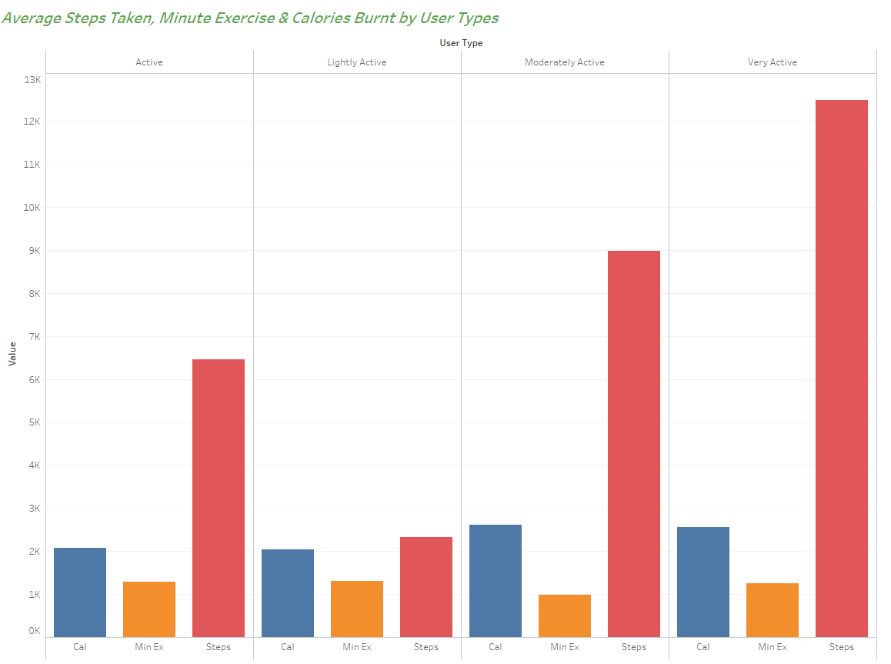

*2nd Graph:*

This graph shows how many recorded instanced of user by the day of the week as our data does not include the user activity for every single day. As we can observe, the Tuesday, Wednesday and Thursday seems to be day when users are more willing to be active and exercise, possible indicating a preference for work-out days.

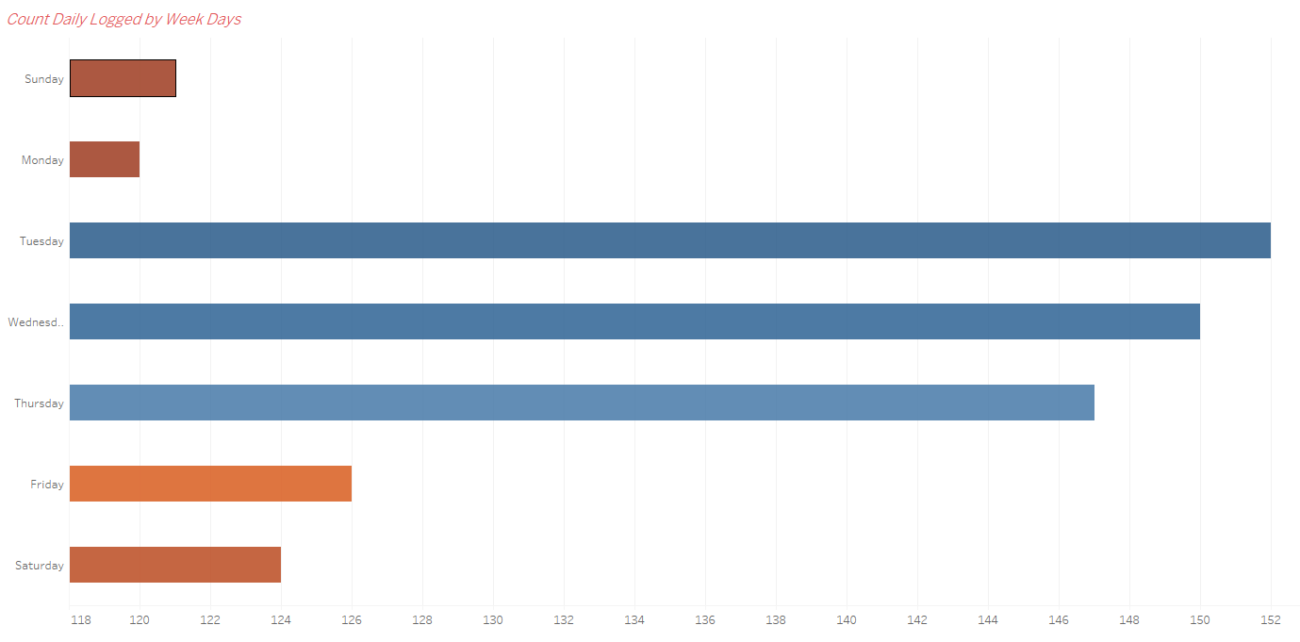

*3rd Graph:*

Following the trend of analysis data for each day of the week, the third graph shows the average total amount of steps taken. Interestingly, Sunday seems to be day with the least activities while Tuesday and Saturday have a good lead on other week days.

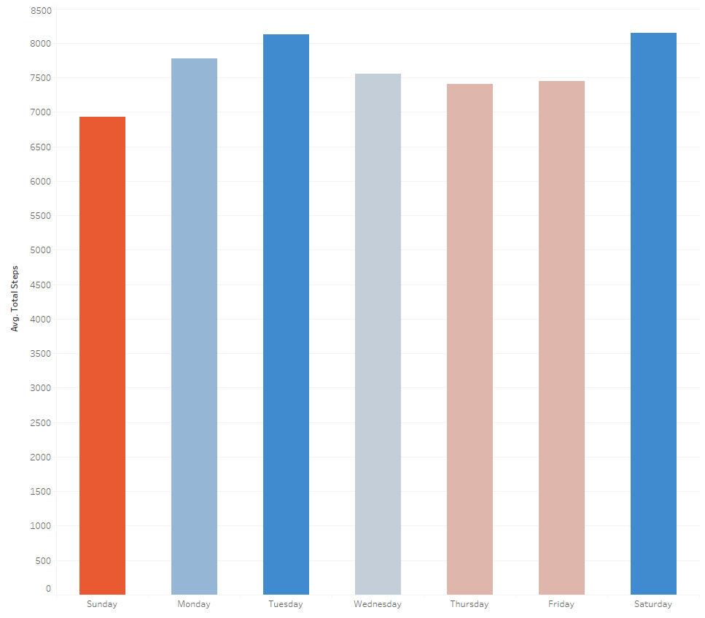

*4th Graph:*

This graph shows the distribution of average calories burnt by the users’ sleeping habits – categorized by their sleep time not by their time in bed. Users who took enough sleep seems to burn the same amount of calories when compared to those who had inadequate sleeping time. People with long sleeps actually burnt the least amount of calories on average. This observation might be due to limitations exist in our data, but it is worth considering regardless.

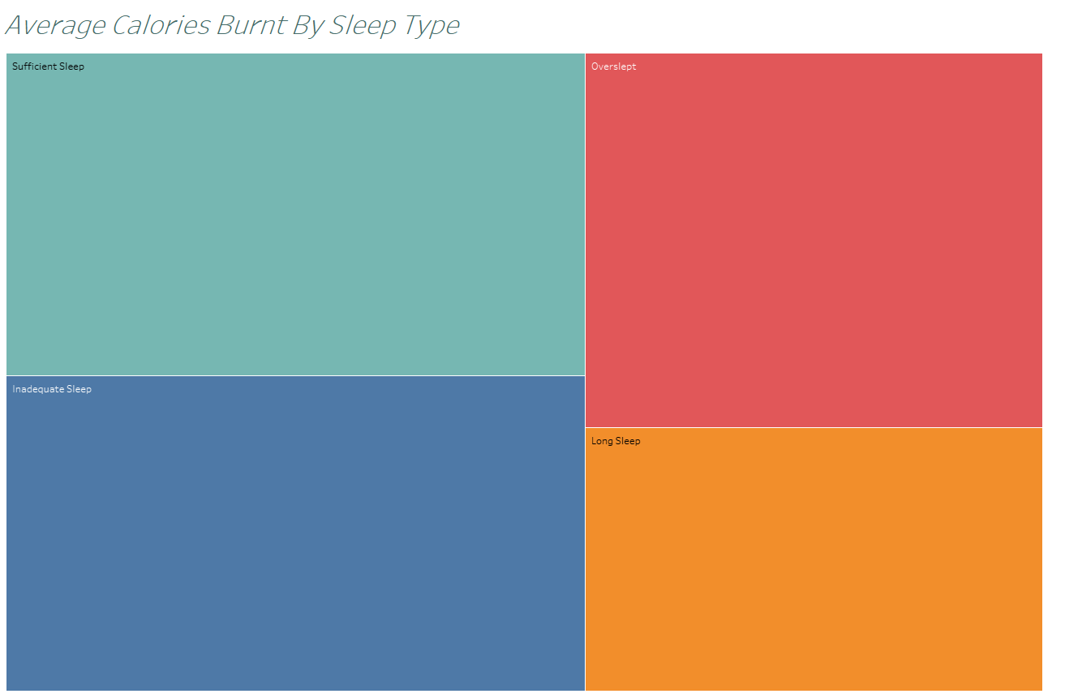

### b. Fitbit Tracker Data Dashboard – Gouri Nandan Reddy Gangavaram

**Link to public dashboard:** <https://public.tableau.com/app/profile/gouri.nandan.reddy.gangavaram/viz/FitnessTracker_Dashboard_1/Dashboard1?publish=yes>

**Data used**: Fitbit Tracker Data.

**Data Pre-processing:**

Here, data is merged from different datasets to get all the important information together in one file for easier further processing and analysing.

Only a few randomly selected samples (ID) are used here to study and identify different interesting exercise patterns between users.

**Graph Details:**

*1st Graph:*

The 1st graph illustrates total no. of steps taken by the subset samples in two different months i.e., April and May. One observation that can be made is that for the same users the no. of steps in the month of April are considerably more than that of in May.

*2nd Graph:*

The 2nd graph illustrates total no. of calories burnt by the subset of user samples in two different months i.e., April and May. One observation that can be made is that increase in the number of steps taken is directly proportional to the no. of steps taken.

*3rd Graph:*

The 3rd graph illustrates each day of the week I.e., Sunday through Saturday, where the selected subset of sample users are Active with the help of using Fairly Active Minutes over the entire day. Here an interesting observation that could be made, is that people tend to be more Active on Sunday & Saturday (Weekends) when compared to weekdays (Monday – Friday).

This set of observation could prove to be very useful for our application where, we can try to introduce more challenges and set goals for different users to make it more interesting overall.

### C. Fitbit Tracker Data Dashboard – Anh Linh Le

<https://public.tableau.com/app/profile/anh.linh.le/viz/vgscore2016/Dashboard1?publish=yes>

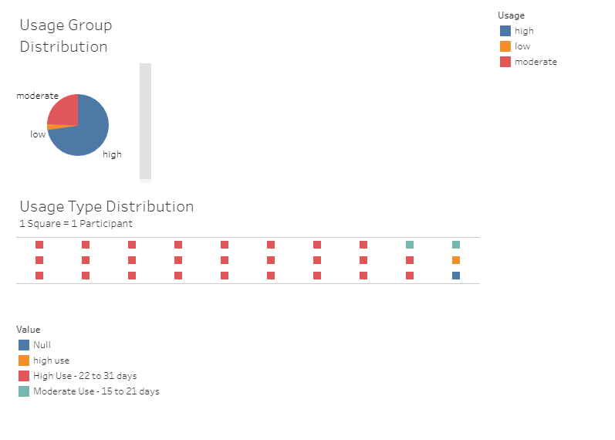

<https://public.tableau.com/app/profile/anh.linh.le/viz/FitbitLeAnhLinh/Dashboard1?publish=yes>

D. Fitbit Tracker Data Dashboard – Bowen Li

**Link to public dashboard:**

[**https://public.tableau.com/views/visual1_16481166176450/1_1?:language=en-US&:display_count=n&:origin=viz_share_link**](https://public.tableau.com/views/visual1_16481166176450/1_1?:language=en-US&:display_count=n&:origin=viz_share_link)

[**https://public.tableau.com/views/VisualizationofFitness/1_1?:language=zh-CN&:display_count=n&:origin=viz_share_link**](https://public.tableau.com/views/VisualizationofFitness/1_1?:language=zh-CN&:display_count=n&:origin=viz_share_link)

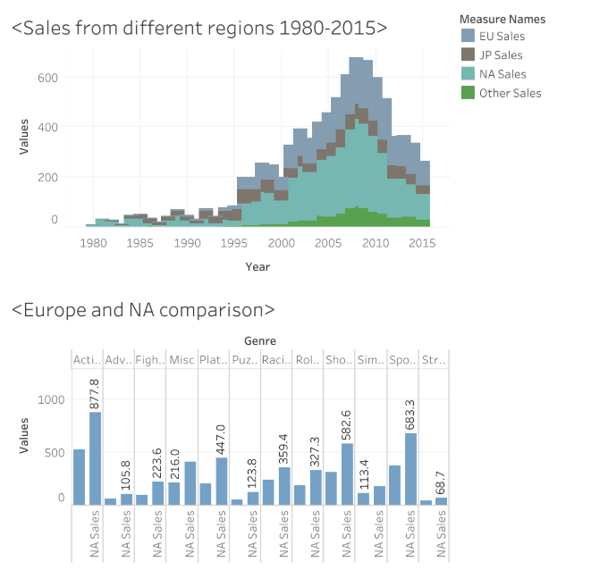

**Data used**: Fitbit Tracker Data.

**Data used**: Video Game Sales Data.

**Graph Details:**

*1st Graph:*

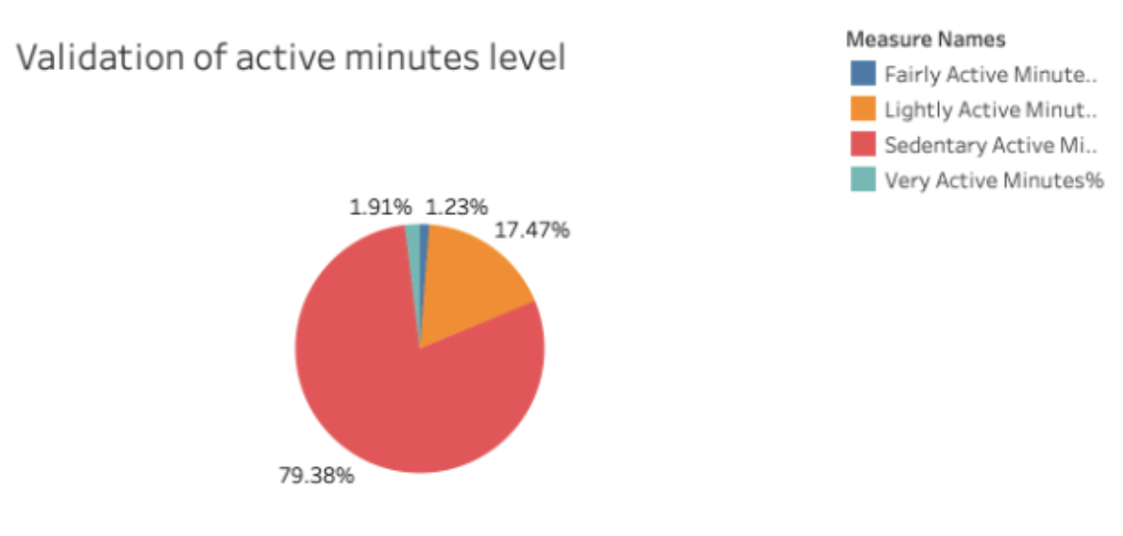

The first graph shows the proportion of different levels of activity minutes in the overall. It can be clearly seen that the proportion of sedentary active minute is the largest and accounts for 79.38% of the total.

*2nd Graph:*

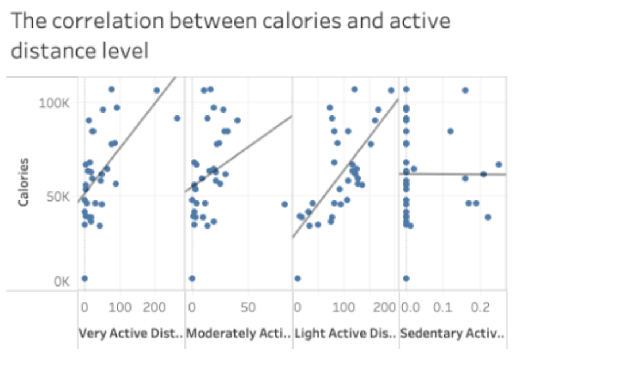

The second graph shows the correlation between calories and active distance level. We can see that there is a linear relationship between the number of calories burned and different levels of active distance. The more intense the activity, the higher the calorie burn.

*3rd Graph:*

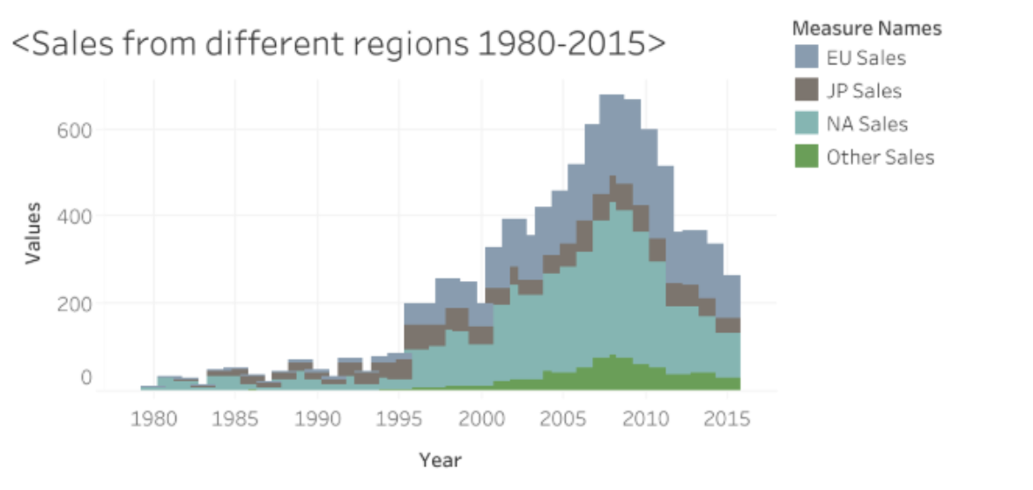

The third graph shows the growth of game sales by different regions from 1980 to 2015. And we can see that from 2000 to 2015, the sales of NA were the best, while the sales in Japan was the lowest. This shows that there is not much enthusiasm for the game in Japan.

*4th Graph:*

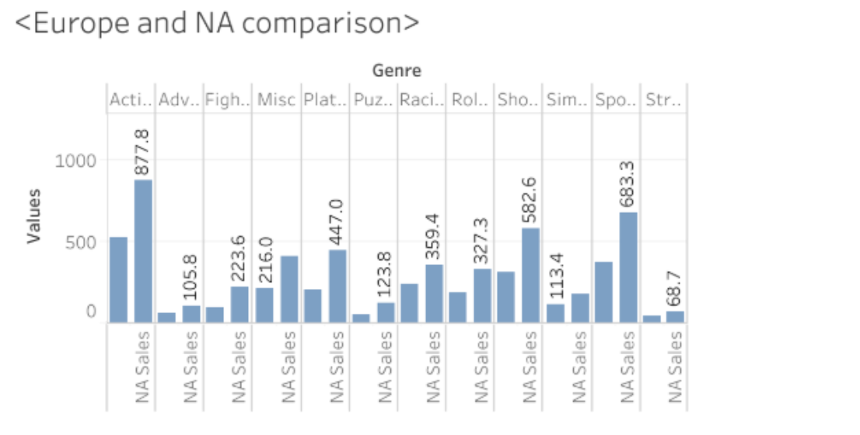

The fourth graph shows sales values in North America and Europe for different genre of games. As we can see from the graph, action games and sports games of sales are the best. For every game genre, north American sales are generally higher than European sales.

### E. Fitbit Tracker Data Dashboard – Xiaolu Li

